**REPORT FOR VIRTUAL ASSISTANCE**

**As a project for Course**

**ARTIFICIAL INTELLIGENCE(INT404)**

PROJECT TITLE:- VIRTUAL ASSISTANCE

Name:-M.Naveen, A.Sreenivas

Reg No:- 11803036,11803023

Program:- B . tech(CSE)

Semester:- 4

School:- School of Computer Science and 0Engineering(SCSE)

Roll No:- 10, 29

Section: K18GA (Group1)

Name of University: Lovely Professional University

Date of Submission:- 12 April

Submitted to: Shabnam

**Table of Contents**

* ABSTRACT
* INTRODUCTION
* Aim
* Motivation
* Context
* Conceptual Framework
* Libraries used and explanation
* Advantages of Chatbots
* Scope of the Project
* Screenshots
* Working
* References
* Conclusion

**ABSTRACT:-**

A virtual assistant is a software agent that can perform tasks or services for an individual. Sometimes the term "chatbot" is used to refer to virtual assistant generally or specifically those accessed by online chat.

**ACKNOWLEDGEMENT:-**

I would like to thank my mentor Prof. Sagar Pande for his advice and inputs on this project. May thanks to my friends as well, who spent their valuable time to listen and provide feedback.

**Virtual Assistant**

**INTRODUCTION:**

**Aim:**

To create a simple AI virtual personal assistant which is used to interact with the user on basis of user inputs.

**Motivation:**

I chose to do this project because I’m in very much excited and interested that how basically the back end of the virtual assistant works as we know on the basis user inputs that how front end will gives the reply to the user very fastly. So, I wanted to work upon the backend and to create an simple AI virtual assistant. Since I’m beginner I wanted to be it simple.

**Context:**

A vitual assistant, also called AI assistant or digital assistant, is an application program that understands natural language voice commands and complete tasks for the user.

In recent years virtual assistants have also worked their way in to many mainstreams and with advent of VOIP services such as skype it has been possible to have a virtual assistant who cananswer your phone remotely without the end user's knowledge.This allows many businesses to add a personal touch in the form of a receptionist without the additional cost of hiring someone.

Such tasks, historically performed by a personal assistant or secretary,include taking dictation, reading text or email messages cloud, looking up phone numbers, scheduling, placing phone calls and reminding the end user about apointments. popular virtual assistants currently include Amazon Alexa, Apple's siri, Google now and Microsoft's cortona.

**Conceptual framework:**

Library used:

1) gTTs - Google Text tp Speech, for converting the given text to speech.

2) Speech_recognization - for recognizing the voice command and converting to text.

3) Selenium - for web based work from browser.

4) Wolframalpha - for calculation given by user.

5) Playsound - for playing the saved audio file.

Advantages for using virtual personal assistant:-

1. make and receive phone calls

2. Add events to a calender

3. control smart home devices

4. Get directions.

**Scope of the Project:**

Milestones:

13/02/2020 -- Learning about Virtual assistant.

15/02/2020 – Applications, Advantage and dis-advantges of virtual assistant.

20/02/2020 – Research about the libraries required to implement for virtual assistant.

05/03/2020 – Setting the code.

11/03/2020 – Testing the code.

19/03/2020 – Rechecking and adding details to the code.

21/03/2020 – Code is completed(code is fully functional).

**Working:**

We can open gmail by saying “ open Gmail “ command

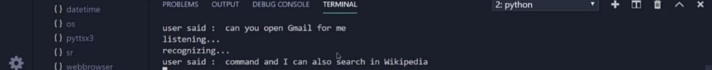

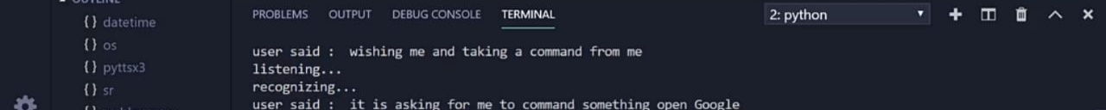



**References:**

* I have researched about virtual assistant from Google.
* I researched and learnt the libraries required for it from You Tube.

**Conclusion:**

Virtual personal assistant, which can perform online tasks on offline condition as we given her local module to her. In online condition virtual assistant gets more resource to work with. Also, any pheripheral which is connected with the internet can be control with the virtual personal assistant just by giving the command.